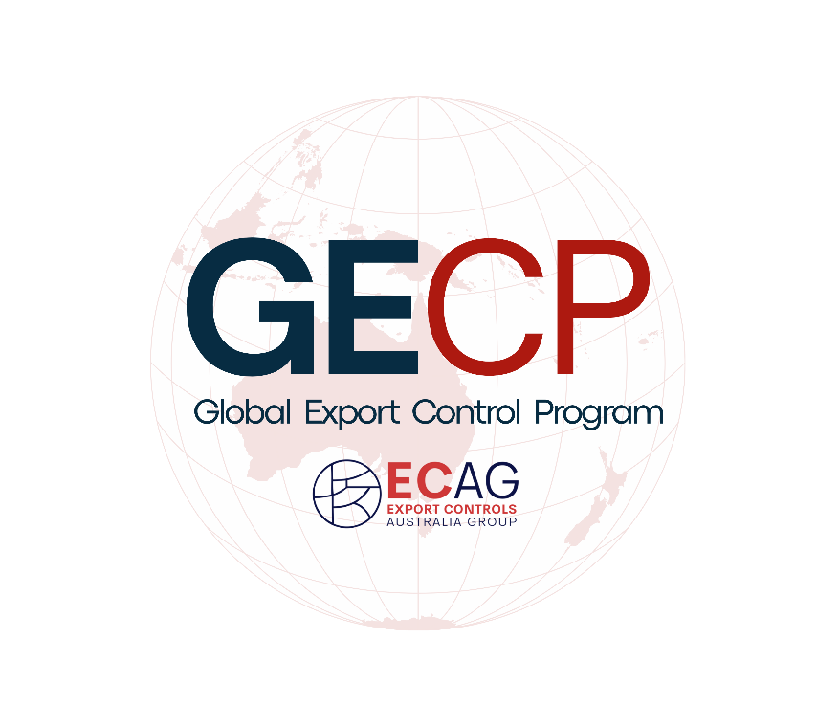
ECAG – Global Export Controls Program (GECP)
Application Pack & Expression of Interest (EOI) Form
Application deadline: 20th November 2025, 23:59 ACST
Contact: gecp@ecag.com.au

Program Overview

The Export Controls Australia Group (ECAG) is offering a fully sponsored professional development program designed to elevate early to mid-career practitioners (2–7 years’ experience) in export controls, sanctions, and related fields across industry, academia, and government. The Global Export Controls Program (GECP) will feature international and global experts, flown in exclusively to share their knowledge. Participants will benefit from expert-led seminars, practical workshops, and more all aimed at building practical capabilities aligned with Australia’s national interests, including AUKUS-related collaboration.

Eligibility (Manadatory)
Please note if you have do not meet the below eligibility, your application will not be considered.

I have 2–7 years cumulative experience in export controls, sanctions, trade compliance, or adjacent roles.
I am based in Australia; I am an Australian Citizen and have the right to work/study in Australia.
The cumulative experience can be from any industry/area, such as Government, Defence, Defence Industry, Academia, Law, Consulting and others.

Required Documents
- CV (max 2 pages)
- This document completed
- Support from your employer

Application Questions
Please answer the following. Word limits are maximums; concise answers are welcome.

Applicant Information:
Full Name:
Today’s Date:
Company:
Job Title:
Email Address:
Contact Number:

Interest & Purpose (max 300 words)
What motivated you to apply for the GECP program, and how do you think it will support your career aspirations and growth?

Problem Statement (max 300 words)
Outline a challenge that you observe or experienced for you, your industry/area or the wider community?

Learning Goals (max 200 words)
List the top three skills/knowledge areas to you would want to grow and build through the program and why?

Other (max 200 words)
Is there anything else you would like us to consider in your application, or any additional comments regarding international export controls?

Submission Instructions
Submit your EOI via email with all materials as a single PDF to gecp@ecag.com.au. Use the subject line: “GECP EOI – [Your Name]”. Incomplete or late submissions may not be considered.

Participant Information
To ensure availability and commitment, a shortlist of candidates will be created. These shortlisted candidates must provide a support letter from their employer and commit to attending all four workshops and associated deliverables, along with any additional required information.

Successful final candidates will be formally offered a place in the 2026 GECP Program cohort. They will receive program details upon their appointment and must confirm their commitment within five days of notification.

